Polycrystalline Structure Diamond Powders
Micron Size Detonated Diamond Powders

Premium Grade

DP3-SC

Scratch-Controlled

Polycrystalline Structure Synthetic Diamond Powders
for Electronic Texturing Applications

UK Abrasives, Inc. is one of three original polycrystalline structure diamond powder manufacturers in the world. The powder manufacturing plant also has its own grading facilities, utilizing state-of-art, and highly customized processing equipment.

As the result of ongoing R&D efforts UK Abrasives, Inc. has recently developed a precisely graded line of Polycrystalline Structure Diamond Powders for electronic industry texturing applications.

DP3-SC grade powder with controlled scratching was developed to bring under control the most critical characteristic of overall powder performance. Special steps in the manufacturing process assure the removal of very minute quantities of coarser particles that cause light and heavy scratching of texturing surfaces.

The final production step takes place in an ISO9001:2000 registered company facility in Northbrook, Illinois (North Chicago Suburb), conveniently located just 20 minutes from Chicago O’Hare International Airport, facilitating local and international deliveries.

Clean room production environment in all production facilities assures contaminant-free products. Polycrystalline Structure Diamond powders are supplied suspended in de-ionized water and have standard shelf life of 1 year.

Among standard powder sizes are 0-0.1 micron, 0.05-0.15 micron and 0.05-0.2 micron. Custom grading is also available.
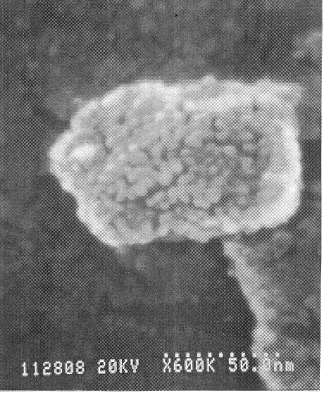
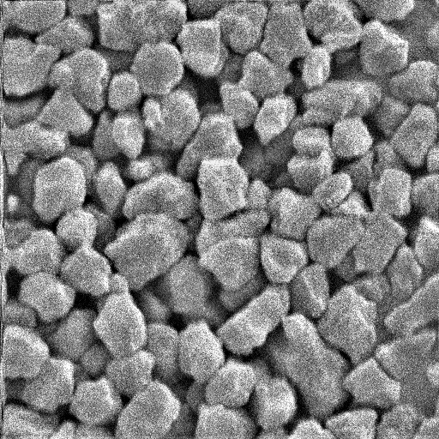
HSEM (High Resolution Scanning Electronic Microscope) pictures of our powder size 0.05-0.2 mcm under 10,000 times magnification. |  | HSEM (High Resolution Scanning Electronic Microscope) pictures of our powder size  0.05-0.2 mcm under 600,000 times magnification. |  | .
Large polycrystalline structure diamond powder inventory, strict quality control, ISO 9002 governed manufacturing and customer service practices along with quick turn-around time make working with UK Abrasives a very pleasant experience.

We are looking forward to work with you on your next project in the very near future.

Bulletin DP3-SC Rev.1 (7.12.2002)

5-1

